**Task 1:** Manually enter data into SPSS.

1) After starting the program, select “*type in data*” and hit “*OK*.”

2) Select “*Variable view*” at the bottom of the spreadsheet.

3) For the first row, type in the variable name “patient” then make sure that the variable type is set at “Numeric.” Do the same for the other four variables, giving them the names “treatmnt,” “thereff,” “changed,” and “adveff,” respectively.

4) Now select “*Data view”* from the bottom of the spreadsheet, and enter the data for each patient. For instance, for person 1, type in “1” under the variable “patient,” then “1” under “treatmnt,” then “1” under “thereff,” then “2” under “changed,” and “2” under “adveff.”

5) Do this for the remaining 23 patients.

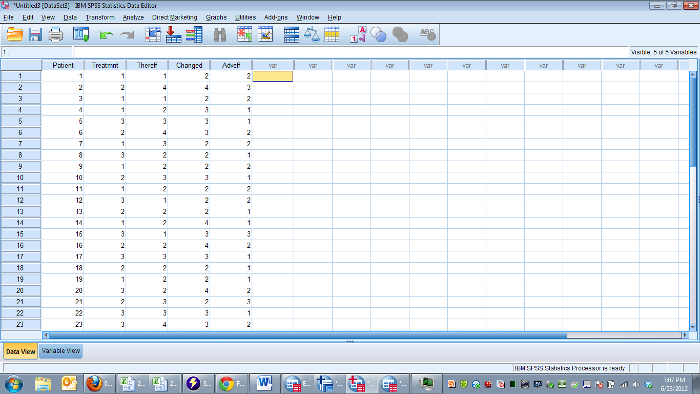

**Task 2:** Compute the mean and standard deviation for the three outcomes (“thereff,” “changed,” and “adveff”) for the group overall (all 24 patients) and for each treatment group.

1) To calculate the overall means and standard deviations, select “Analyze,” “Descriptive Statistics,” and “Descriptives.” Select the three outcome variables in the left-hand column and move them into the right-hand column called “variables.” Select “Options,” and make sure that at least “mean” and “standard deviation” are selected. Hit “Continue” and “OK.” The mean and standard deviation should be shown in a table in the Output window.

2) To calculate the means and standard deviations for Treatment Group 1, select “Data,” then “Select Cases,” then “If condition satisfied,” then “If.” Select the variable “Treatmnt,” and move it into the text box on the right. After the word “treatmnt,” type in “=1”. Hit “Continue” and “OK.” The dataset should now show lines “crossing out” the patients that are not in Group 1. With Group 1 selected, engage in the same process as above to calculate the mean and standard deviations.

3) To calculate the means and standard deviations for Treatment Groups 2 and 3, engage in the same process, but type in “=2” and “=3,” respectively.

|  |  |  |  |  |  |  |
| --- | --- | --- | --- | --- | --- | --- |
| Report your answers by creating and filling in a table that looks like the following. Round each answer to the hundredths place (two digits to the right of the decimal point). Treatment Group | Mean thereff | S.D. thereff | Mean changed | S.D. changed | Mean adveff | S.D. adveff |
| 1 | | | | | | |
| 2 | | | | | | |
| 3 | | | | | | |
| Overall | | | | | | |

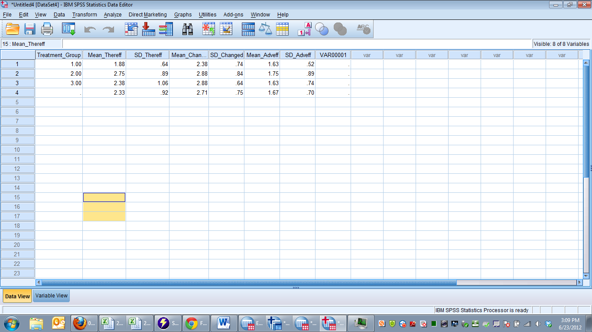

**Task 3:** Create a histogram of “therapeutic effect” for each treatment group (you don’t need to do this for the overall group). Do this by selecting the appropriate group (via the data selection process described earlier), and then select “Graphs” and then “Histograms.” Move “thereff” into the variable box and hit “OK.” Cut and paste these graphs into your final homework draft. Make sure to label each graph appropriately (such as “Histogram of Therapeutic Effects for Treatment Group 1.”).

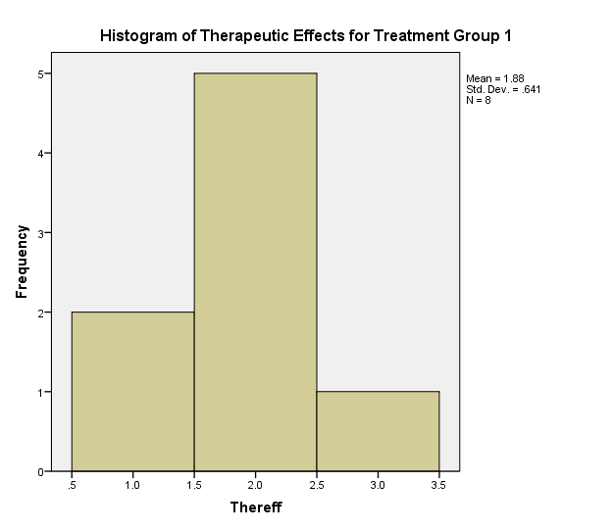

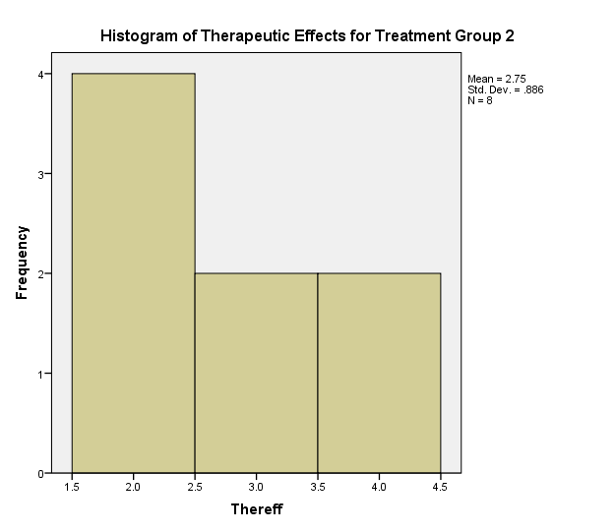

50% of users for drug one felt moderate change and the remainder felt little to know change. When taking any drug, it has tradeoffs. With only a 50% moderate increase in therapeutic effectiveness I do not think I would recommend this drug.

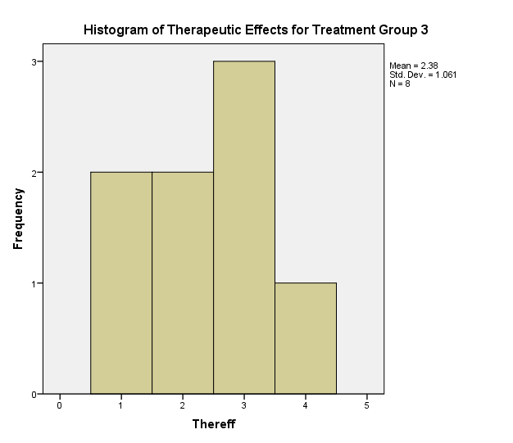

Drug 2.

25% of participants felt marked changes, another 25% felt moderate. Of the remaining 50%, 75% felt minimal change and 25% no change. For this drug I would want further research done on the top 50% to see if we could further distinguish and increase the therapeutic success rate before prescribing this medication. This drug is better than the first drug, but compared to the placebo it is not making that big of a difference. I would not prescribe this drug.

**Task 4:** What do you think about the relative effectiveness of the two treatments? Discuss the effectiveness of the treatments in relation to each other and to the placebo for a non-statistician audience. Are the treatments effective? How do you know? Which treatment is better? Why? If you had to recommend a drug, which would it be? What is your evidence for your recommendation? Don’t just repeat the numbers here. Make sure to interpret the analyses you’ve done.

In explaining the results, I will compare both drugs to the placebo group, given the placebo are the point of reference for the general public. 85% of the placebo group felt some type of improved change in the experiment. 50% of the placebo group felt moderate to marked changes. This is extremely high for a sugar pill that really has no negative side effects on its patients.

Drug 1.